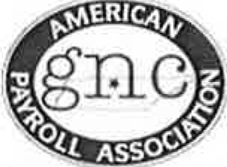

GNC APA Chapter Meeting Minutes
.

November 16, 2017
11 :45 a.m. - l :30 p.m.

www.apanashyillctn.org

11:45 a.m.
12:06 pm
Registration and Buffet Line Amy Duffer (President)

Opening Remarks and Announcements

- Recognition:
  - Charla Daley, CPP (speakers) and Melinda Stewart (one-day seminar)

- Officer Elections - Online elections open Nov 16 t h - 30 ^{th} .
  - Anne Marie Fleck, CPP Nomination Committee Chair, & Kay Stauffer, CPP

- Spring Study Group - session leaders wanted also location needed - contact Katya Manning,
CPP if interested. Katya also mentioned the need for a room that will accommodate around 20 people. The classes will run from January 1, 2018 – March 29, 2018.

- Job Opportunities - Several open opportunities in the Nashville area. Check out the website for more details.

- Upcoming National Events
  - Congress - National Harbor, MD - May 15 - 19, 2018.

12:04 p.m. Valerie Phillips, CPP (Director of Membership): Membership Update
129 Members/84 APA/63 CPP/6 FPC/3 CPA/4 PHR-SPHR/2 SPHR-CP/2 SHRM-SCP/3 ADP-CPS/80 Companies

12:05 p.m. Janet McReynolds, CPP (Secretary):
Charla Dailey, CPP & Bonetta Bond, FPC 2nd

12:06 p.m. Bonetta Bond, FPC (Treasurer): $14,438.03

Meeting Minutes Approval

12:10 p.m. Charla Dailey, CPP (Director of Education) Guest Speaker Introduction

Guest Speaker: Charles Duncan
Never Give Up

1:00 p.m.

Amy Duffer Door Prizes and Adjournment

Next meeting: December 14, 2017 Millennium Maxwell House Hotel 2025 Rosa L Parks Blvd, Nashville, TN 37228
615-259-4343

