APR Officer Board Meeting
April 2, 2020
12:30PM to 130PM
Call In Number: 712.770.4340
Participant ID 734147

Officers in Attendance:
President: Patsy Campbell, CPP
President Elect: Charla Dailey, FPC
Secretary: Valerie Phillips, CPP
Treasurer: Melinda Stewart, CPP
Membership: Robert Buck, CPP
Education: Vicki Hill, CPP
Public Relations: Lisa Wachter, CPP
APA Liaison: Debbie Rule, CPP
Government Liaison: Darlene Greer, CPP
Director of NPW: Tara Martin, CPA
Community Service: John Kenney, CPP
Past-President: Bonetta Bond, FPC

- Patsy Campbell, CPP: Welcome and call to order

Old Business

- Valerie Phillips, CPP: Approval of minutes from April meeting
- Melinda Stewart, CPP: Treasury Update and review of expenses
- Robert Buck, CPP: Membership Update
- Vicki Hill, CPP: Speaker Update for May Meeting
  - Will discuss Virtual meting information during new business
- Debbie Rule, CPP: APA updates
- Darlene Greer, CPP: Government Updates
- John Kenney, CPP: Community Service updates
- Patsy Campbell, CPP: Chapter Member/Friend for May

New Business

- Patsy Campbell, CPP:
  - Emailed Hotel concerning May meeting and reopening of the hotel for events
  - Virtual Meeting
    - Chapter options for virtual technology
    - Chapter survey on charging, and thoughts on this
  - Vendor Sponsorships-Tiered approach seems to be the approach.
    - If no ideas on this, we will put it on hold
  - Committee formation update
    - Feel like this should be on hold until a later date
  - ½ Day Seminar Discussions
    - Should we put this on hold until further notice?
  - NPW -Need to start planning!!!!!!!
  - 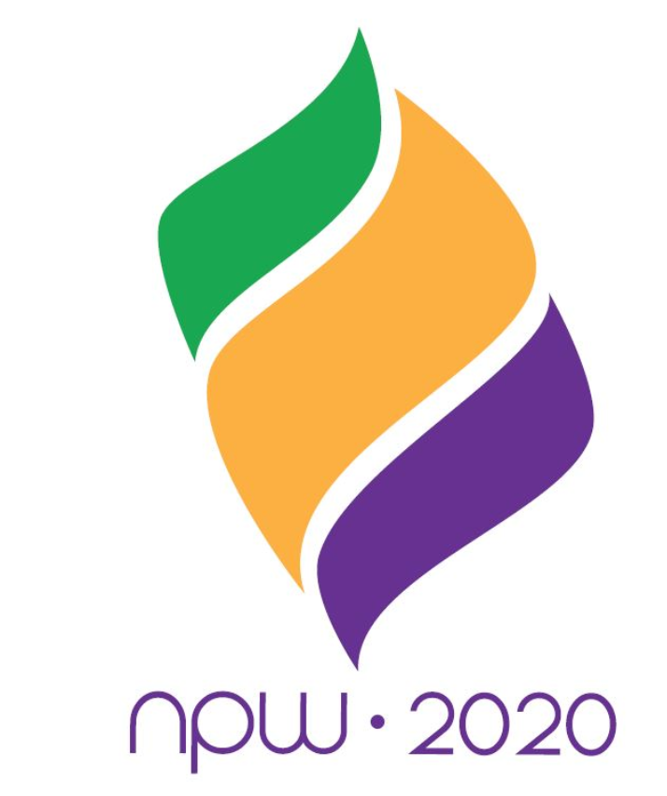
For 2020, you’re invited to join Team Payroll USA as we bring home the gold during the NPW “Paylympics” celebration. This year’s official artwork design was inspired by modern day Olympic games posters but features a unique payroll twist. The flame of payroll excellence that is the focal point of this year’s artwork is created from stylized paychecks in the official NPW colors of green, gold, and purple.

  - Other New Business
  - Next Meeting June 4, 2020
  - Adjournment

